W9 PRACTICE
Async CRUD & Firebase

 Learning objectives
- Handle the fetching flow:
  - Send requests
  - Handle failures
  - Convert JSON into objects

- Interact with Firebase
- Perform CRUD operations with Firebase

How to submit?
- Push your final code on your GitHub repository
- Then attach the GitHub path to the MS Team assignment and turn it in

 Before practice, to be prepared!
Read the following documentation to be ready for this practice:

Fetch data from the internet
Firebase REST API

EX 1 – A simple button status

💡NO start code provided

- Create a very simple firebase collection of 2 data, representing a button status:
  - A title (String)
  - A selection (boolean)

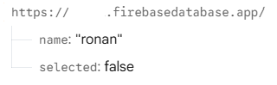

- Create a simple screen (Stateful widget) displaying a selectable button
- Note : you can separate the button widget (stateless) from the screen (stateful)
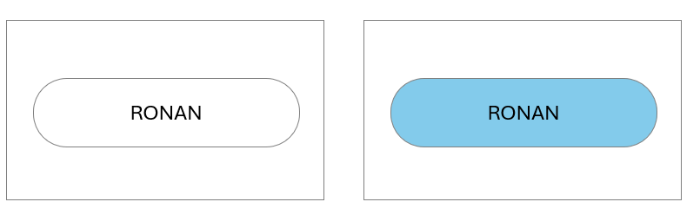
The button can be selected or not selected

- Overwrite the initState method to fetch button data from firebase

@override
void initState() {
super.initState();

// Fetch init state
_fetchButtonData();
}

- Implement the fetchButtonData and handle the 3 states of the asynchronous fetch operation.

void _fetchTodos() async {
setState(() => data = AsyncData.loading());

try {
<YOUR CODE>
setState(() => data = AsyncData.success( <YOUR CODE> ));

} on RepositoryException catch (e) {
setState(() => data = AsyncData.error(e.message));
}
}

- Create a repository to fetch the button data (title + completed).

Future<ButtonStatus> getButtonStatus() {
// 1- Fetch the data from firebase (Map<String, dynamic)

// 2- Create a ButtonStatus to handle the data and return it

// 3 also handle possible errrors (no connection...)
}

- Finally combine the code and test it.
- What happen is no wifi?
- What happen is the firebase data structure does not contain what you expect?

EX 2 – A full Todo List App

💡Start code provided

For this exercise, we need to create a database in Firebase and implement the bellow operations

- Fetch the list of to-do items (mandatory)
- Mark a to-do as completed (mandatory)
- Add a to-do item (optional)

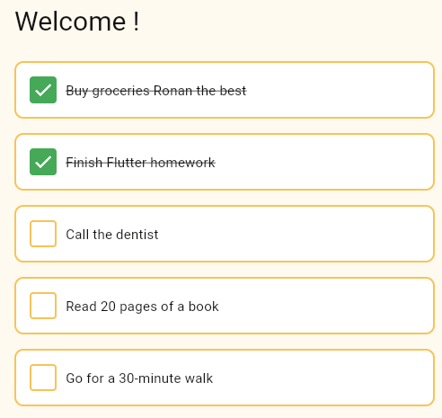

⚠️ TO complete this practice, you can either:

- Start from scratch and build your own code entirely
- Follow this step-by-step approach

- You can also do both: first follow the step , then build your own code

STEP 1 – Fetch the list of TODO from the repository (simulated data)

For now, the screen displays the not started state:

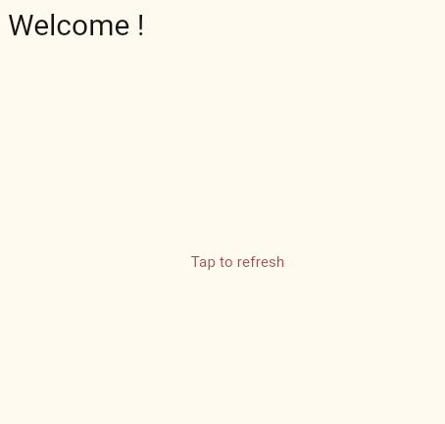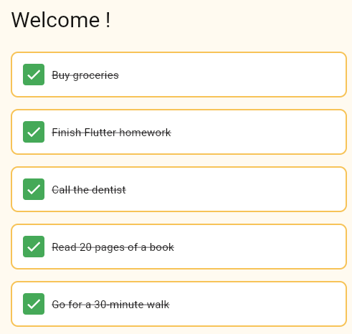
What we see / What we expect

In the TODOS screen:
- Fetch the data from the repository (for now it s fake data)
- Handle success, loading and error cases (catch exception)

STEP 2 – Adapt the TODO card

For now, all TODO cards are displayed the same way.

Depending on the TODO status (completed / not completed) you should display the card as follows:

COMPLETED
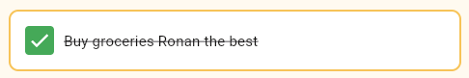

NOT COMPLETED
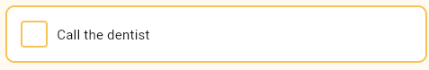

In the TODO card:
- Update the widgets to display both states (completed / not completed) as required

STEP 3 – Update the TodoDto

- Complete the function fromJson in TodoDot in order to convert a JSON data to a Todo object

static Todo fromJson(String id, Map<String, dynamic> json) {
// Assert the map contains the keys
// Return the right todo
return Todo(id: "fake", title: "fake", completed: false);
}

- Test your function :

Run the main provided in the TodoDto file and ensure we can decode a list of to-do from a given String

dart .\todo_dto.dart
Instance of 'Todo'
Instance of 'Todo'
Instance of 'Todo'

Display the 3 TODO you have created in the console

STEP 4 – Fetch the list of TODO from the repository using firebase

- Create a firebase collection providing the list of todos, as required by the model

- Update the repository getTodos function to fetch data from your firebase collection

- Call your TOdoDto for convert your data to a list of Todo objects

- Handle the possible issues (response.statusCode is different from 200)

STEP 5 – Update the repository to handle the updateCompleted function using firebase

- Update the function to change a given todo completion status (completed / not completed) :

- Build the Firebase URL targeting a single todo using todos/{todoId}.json
- Use PATCH to update only specific fields instead of replacing the whole object
- Encode only the field to update (completed) into a small JSON body
- Send the request and wait for Firebase response
- Check the status code to confirm the update succeeded (200)
- Throw a RepositoryException if the update fails to propagate the error cleanly

